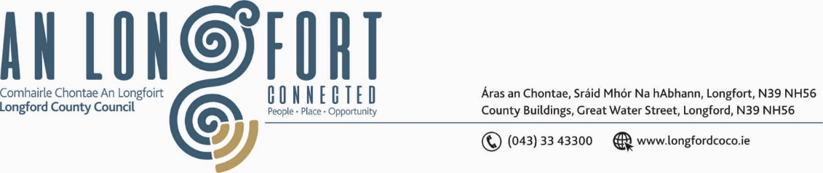

**GRANARD MUNICIPAL DISTRICT**

***Please note meeting will be held in Granard Library.***

**16th July 2021.**

**To: Each Member of Granard Municipal District.**

**Dear Member,**

You are requested to attend the Meeting of Granard Municipal District to be held

**Granard Library** on **Tuesday, 27th July 2021 at 3.30pm** to transact business, as set out on the Agenda hereunder.

**Yours sincerely**,

Ann Marie Mc Keon

______________________

**Ann Marie Mc Keon,**

**Meetings Administrator.**

**AGENDA**

Prayer before meeting.

**1.** Confirmation of Minutes as follows: -

* Granard Municipal District Committee Meeting held on 25th May 2021 – copy enclosed.
* Granard Municipal District Meeting held on the 25th May 2021 – copy enclosed.
* Granard Municipal District Annual Meeting held on 22nd June 2021 – copy enclosed.

**2.** Matters arising from Minutes.

**3.** Declaration of Interest by Members.

**4.** Management Report incorporating Area Engineer’s Progress Report

- to follow.

**5.** Risk Assessment RA-CV-031- Attendance at Council meetings by Elected

Members and Council Officials /Others (Media and Public) and attendance at other

meetings or council buildings – enclosed.

**6.** Granard Public Art Features.

**7.** Proposed Projects/Expression of interest – enclosed.

**8.** Consideration of applications for funding under the 2021 Community Grant Support

Scheme – list enclosed.

**9.** Part 8, No. 87 Construction of a path to enhance existing heritage and amenity trail in

the village of Aughnacliffe. Report in Accordance with Section 179 of the Planning

and Development Act 2000 (as amended) and Part 8 of the Planning and Development Regulations 2001 (as amended).

**10.** Notices of Motions, submitted by Councillors, as listed hereunder –

**Councillor Turlough Mc Govern**

That Granard Municipal District recognise Erin Ross for her achievement on winning the All Ireland Scór Na nOg (singing) in February 2020, when covid restrictions are lifted.

**Councillor PJ Reilly**

(i) What plans have the Council for the area of ground that they purchased from the

OPW for a public car park to facilitate the traffic issues in Granard.

(ii) I call on Longford County Council to erect crash barriers on the bend where there was a fatal accident recently on the road at Castlenugent, Lisryan.

**Councillor Paraic Brady**

1. I call on Longford County Council to get in contact with Irish water as a matter of emergency to fix the raw sewerage that is flowing down the street of Drumlish for the last 3 years outside Gallaghers.
2. We request an update on our Drainage program for North Longford regarding the Black River, Lough Uchter and Lough Gowna and have the Council heard from our neighbours in Leitrim and Cavan Council.

**Councillor Paraic Brady and Councillor Colin Dalton**

I call on Longford County Council to notify all landowners of hazards or dangerous trees on our back lanes and bye roads and especially on lanes where Local Improvement Schemes works are to be carried out.

**Councillor Garry Murtagh**

(i) I call on Longford County Council to consider a low-cost safety scheme at the junction adjacent to Annagh Swimming pool. It is presenting as an extremely dangerous junction for motorists to access the R198, in particular from traffic turning right and from oncoming traffic from the Arva direction.

(ii) I call on Longford County Council to review the entrance into the public amenity at Dring car park, the sight lines are particularly difficult exiting the car park. Consideration of signage or road markings on the approach in particular from Granard direction, for motorists to express caution at a concealed entrance.

(iii) I request an update from the roads department on a previous Notice of Motion requesting consideration for the use of laminated signage for the refurbishment of directional signage in county Longford. This is a cost-effective solution to mindless vandalism of our national road signage and the cause of untold repetitional damage to tourism in north Longford.  When can we expect some progress on the issue of signage?

**11.** Correspondence from Irish Water dated 8th June 2021 – enclosed.